**Task 1: LOD**

**LOD(fixed)**

1. This is used to show the top most values of the measured values.
2. We create this parameter to know the top numbers we desired in our LOD.

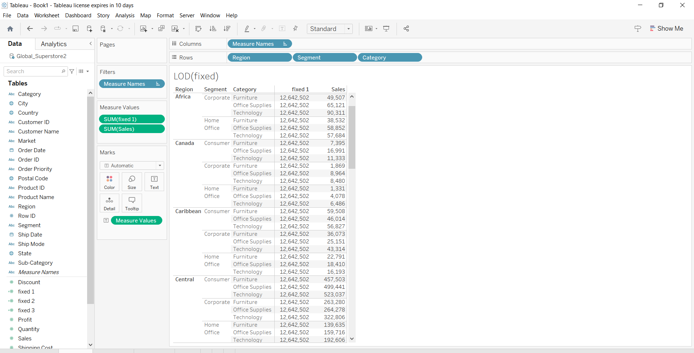

3.by above calculation we can create our desired LOD(fixed).

4. the end result will be shown as above.

**LOD(include)**

1. This is used to show the top most values of the measured values.
2. We create this to know the top numbers we desired in our LOD.

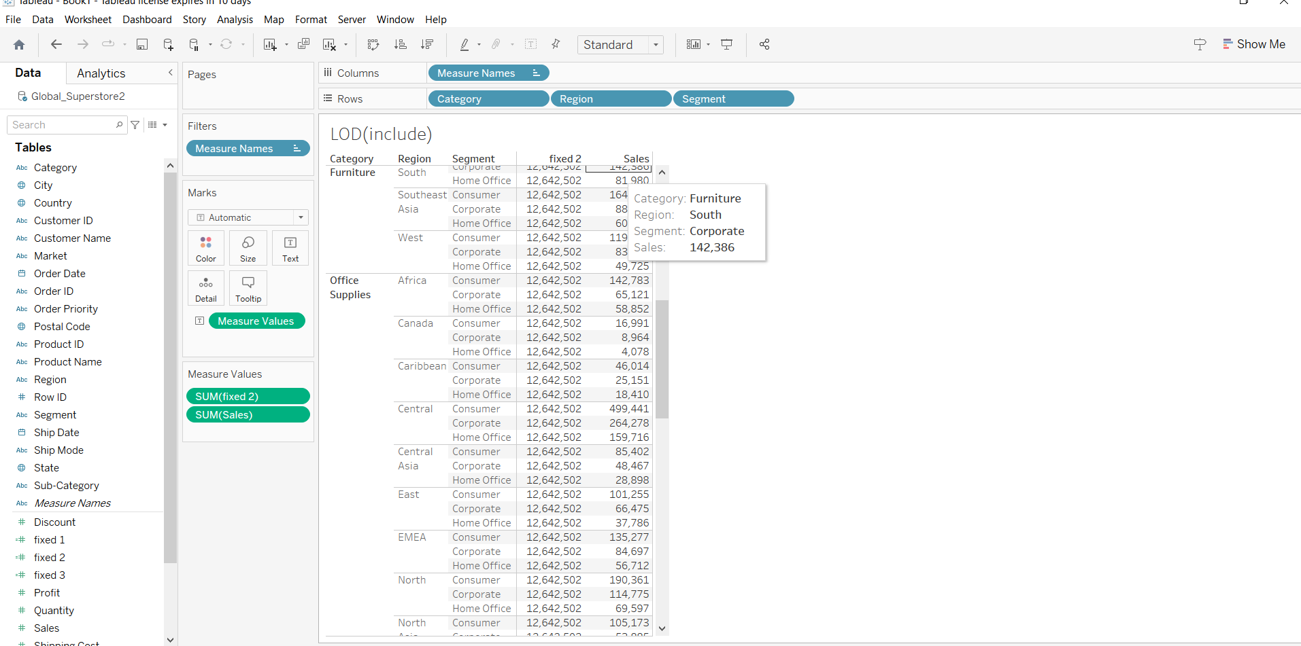

1. By above calculation we can create our desired LOD.
2. The end result will be shown as above.

**TASK 3: PARAMETERS**

**TOP N PARAMETERS**

1. This is used to show the top most values of the measured values
2. We create this parameter to know the top numbers we desired in our parameters.

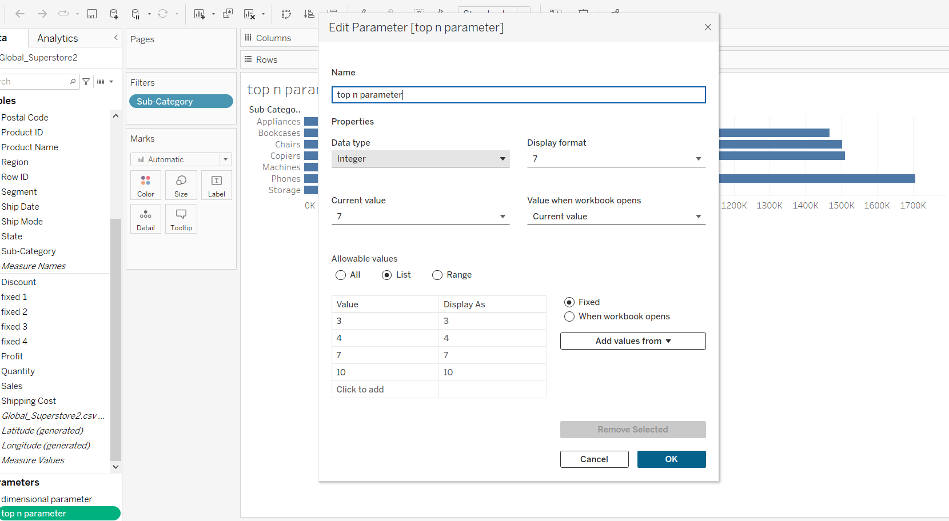

1. By above parameter calculation we can create our desired top n parameter.
2. The end result will be like shown in below.

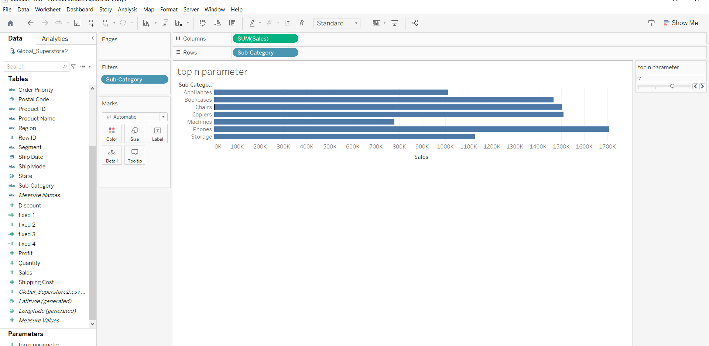

**DIMENSIONAL PARAMETERS**

1. This is used to show the top most value of the measured values.
2. We created this parameter to know the top numbers we desired in dimensional parameters.

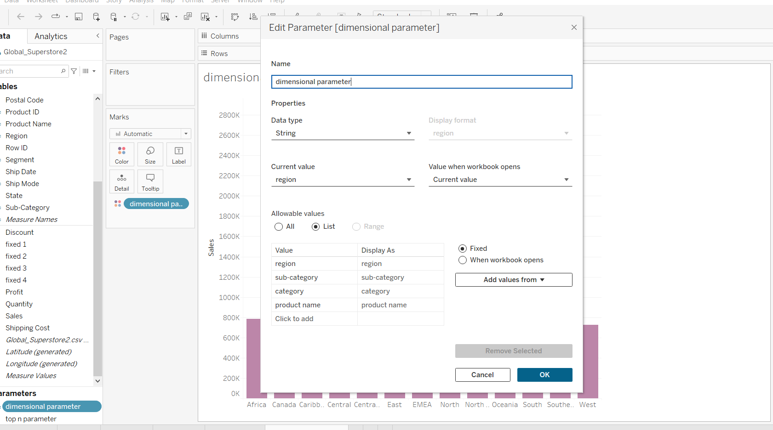

1. By above parameter calculation we can create our desired dimensional parameters.
2. The end result will be shown as below.

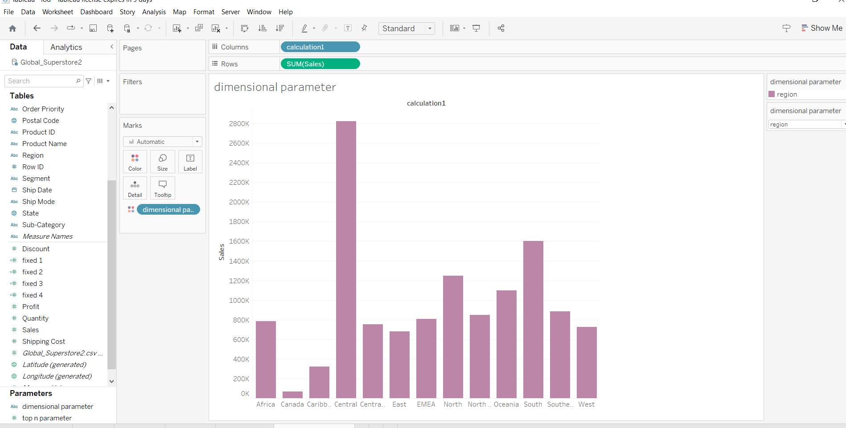

**TASK 3: MAPS**

**POLYGON MAP**

**ATTRIBUTES: Country including longitude and latitude , Profit , State**

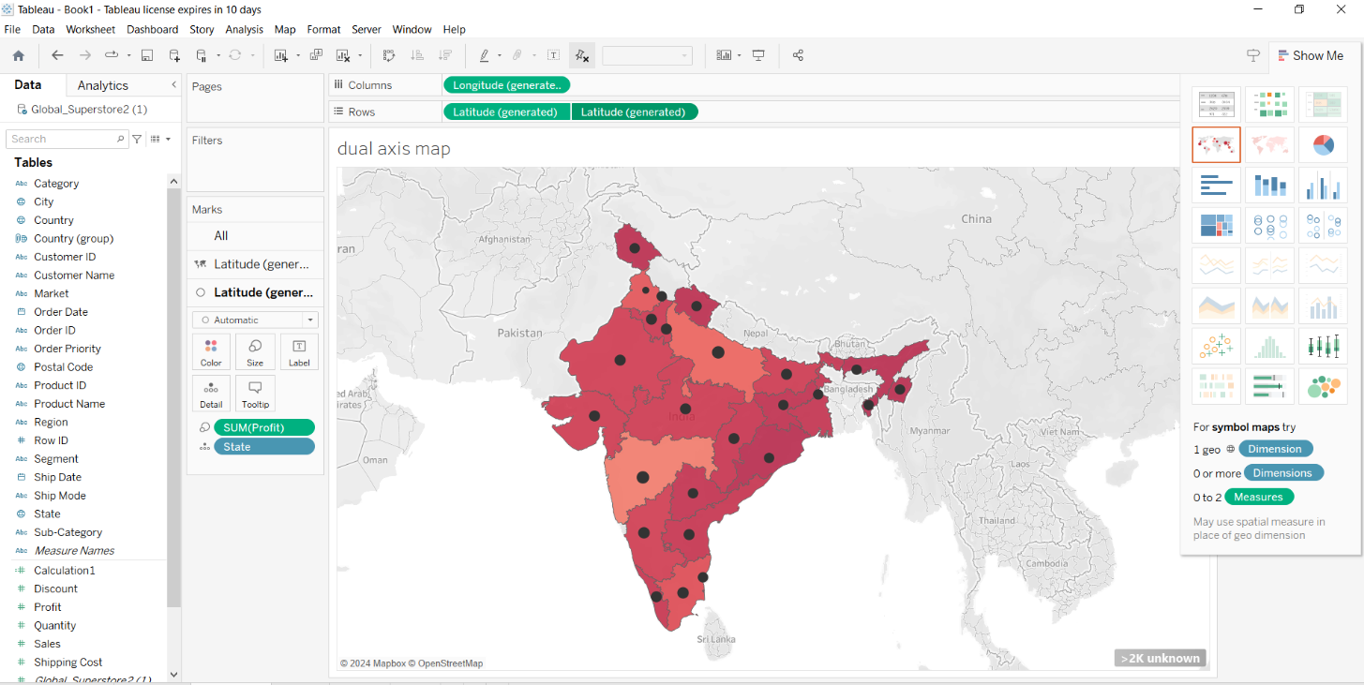

1. A polygon map represents geographic areas using colored polygons such as counties, states, or countries.
2. Each polygon is associated with a data value, allowing you to easily visualize variations in the data across different regions

**FILLED MAPS**

**ATTRIBUTES: Country(longitude and latitude), Profit , Sales , State.**

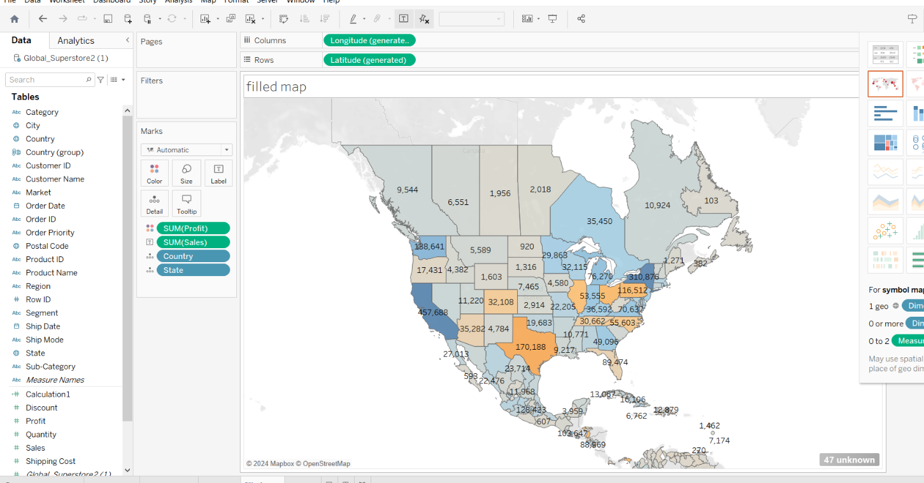

1. A filled map is that displays polygon shapes corresponding to geographical borders such as country or state borders.
2. Filled maps in tableau are similar to symbol maps, but they include many more data points.
3. While a symbol map draws a symbol at the intersection of each latitude and longitude pair.